  

**Salesforce Administration Solution**

**WORKFORCE ADMINISTRATION SOLUTION (DEV)**

1. **PROJECT OVERVIEW I NTRODUCTION**

The Workforce Administration Solution is a comprehensive tool designed to streamline HR and employee management processes. Built on Salesforce, it integrates core workforce functionalities like data management, user collaboration, and workflow automation. The solution aims to improve efficiency by automating repetitive tasks and providing actionable insights through dashboards and reports. It supports scalability, ensuring it can adapt to growing workforce needs. Its intuitive design promotes user adoption while minimizing training efforts. Key components include custom objects, tabs, roles, and permissions. This solution also ensures secure data handling and seamless collaboration via Chatter groups. Overall, it empowers organizations to manage their workforce effectively.

**Use Case:**

This solution addresses workforce management challenges like employee onboarding, role approvals, and reporting processes. Managers can track team performance and plan resource allocation efficiently. Employees can access personalized dashboards to track tasks, leave applications, and approvals. It eliminates manual processes, reducing errors and delays. Integration with third-party applications enhances functionality. Use cases include payroll management, compliance tracking, and internal communication. Overall, it improves transparency, collaboration, and decision-making.

**Salesforce Objects:**

Custom objects form the backbone of the solution, storing workforce-related data. Key objects include:

1. Employee: Tracks employee details like name, role, and department.
2. Leave Request: Manages leave applications and approvals.
3. Performance Review: Logs employee performance evaluations.
4. Task Management: Tracks employee tasks and deadlines.  
   Each object has custom fields to capture specific data, ensuring the system aligns with business requirements. Relationships between objects ensure seamless data flow, improving operational efficiency.

  

**Tabs:**

Tabs provide an interface for users to access Salesforce objects and features. Key tabs in this solution include:

1. **Employee**: Displays employee profiles and related details.
2. **Leave Requests**: Tracks applications and approval statuses.
3. **Reports**: Access performance and workforce reports.
4. **Dashboards**: Visualizes key metrics for quick insights.
5. **Chatter**: Enhances communication and collaboration.  
   Custom tabs ensure users can easily access data relevant to their roles, improving navigation and usability.

**The Lightning App:**

The Lightning App offers a modern and dynamic interface to manage workforce operations. It consolidates tabs, objects, and components in one place for better user experience. Key features include customizable navigation bars, drag-and-drop components, and dynamic dashboards. The app enhances productivity with its intuitive design and speed. Admins can tailor it to specific user needs, enabling role-based access. Integration with other Salesforce features like Chatter ensures seamless collaboration. The app also supports mobile usage, making it accessible anytime, anywhere. This boosts user engagement and operational efficiency.

**Fields and Relationships:**

Fields capture specific data points, while relationships define how objects interact. For example:

* **Fields**: Name, Email, Department, Role, Joining Date.
* **Relationships**:
  + **Lookup Relationship**: Employee ↔ Manager.
  + **Master-Detail Relationship**: Leave Request ↔ Employee.  
    Custom fields like "Experience Level" or "Performance Rating" align with business needs. Relationships ensure seamless data flow between objects, enhancing report accuracy and user experience.

**Setting OWD (Organization-Wide Defaults):**

OWD determines the default access level for records. In this solution:

* **Public Read Only**: Employee Directory.
* **Private**: Performance Reviews and Leave Requests.  
  Admins define OWD based on organizational policies to ensure data security. Role hierarchies and sharing rules enhance data accessibility where needed. OWD settings minimize unauthorized access while promoting collaboration. They balance data security with operational efficiency, critical for workforce administration.

  

**User Adoption:**

Driving user adoption is critical for project success. Strategies include:

1. **User Training**: Comprehensive sessions for different roles.
2. **Intuitive Design**: Simplified navigation with Lightning App.
3. **Chatter Integration**: Enhances communication and collaboration.
4. **Feedback Mechanisms**: Regular user feedback for improvements.
5. **Incentives**: Encourage usage with gamification techniques.  
   These measures build user confidence and ensure the solution’s functionality aligns with real-world needs.

**Import Data:**

Data import ensures seamless onboarding of existing records into Salesforce. Tools used include:

1. **Data Loader**: Handles large data sets for objects like Employees and Leave Requests.
2. **Import Wizard**: Facilitates simple imports for smaller data sets.  
   Admins must ensure data accuracy by cleaning and validating it before import. Mapping fields correctly is critical to avoid errors. Post-import validation ensures no data loss or mismatches. Automation rules streamline future imports, improving efficiency.

**Profile:**

Profiles define a user’s permissions and access rights. Key profiles include:

1. **HR Admin**: Full access to manage employee records and approvals.
2. **Manager**: Limited access to team data and reports.
3. **Employee**: Access to personal records and limited dashboards.  
   Profiles ensure users have the right access levels, aligning with their roles. This protects sensitive data and streamlines operations.

**Role:**

Roles define data visibility based on organizational hierarchy. Examples include:

1. **CEO**: Full access across all records.
2. **Department Manager**: Access to department-specific records.
3. **Employee**: Limited access to own records.  
   Roles work with OWD and sharing rules to manage access. They ensure managers can view team data while employees focus on their personal tasks, maintaining data integrity.

**User:**

Users are individuals with access to the Salesforce instance. Each user is assigned a profile and role. For example:

* **HR Manager**: Profile: HR Admin, Role: Department Manager.
* **Employee**: Profile: Employee, Role: Staff.  
  Admins create users and ensure proper credentials are assigned. User records include details like email, username, and department. Proper user management ensures smooth operations and security.

  

**2 OBJECTIVES**

Objective for Salesforce Administration Solution

To streamline and optimize business processes by implementing and managing Salesforce CRM solutions, ensuring efficient data management, improved customer interactions, and enhanced team productivity.

Key Goals:

1. Centralized Data Management:
   * Consolidate customer data in a single, secure, and accessible platform.
   * Enable real-time data access for improved decision-making.
2. Automation of Processes:
   * Automate routine tasks like lead assignment, email follow-ups, and approval workflows.
   * Minimize manual errors and increase operational efficiency.
3. Enhanced Customer Engagement:
   * Track and manage customer interactions for personalized service.
   * Improve customer retention and satisfaction through timely communication.
4. Comprehensive Reporting and Analytics:
   * Generate detailed reports for sales performance, customer trends, and pipeline health.
   * Leverage insights to refine strategies and forecast revenue.
5. Scalability and Customization:
   * Build scalable solutions to adapt to organizational growth.
   * Customize Salesforce features to align with specific business needs.
6. User Training and Adoption:
   * Provide training and support to ensure seamless adoption by team members.
   * Empower users to leverage Salesforce to its full potential.

**STRATEGIC BUSINESS GOAL DOMAINS:**

1. **CLIENT MANAGEMENT TRANSFORMATION**

The client management strategy transcends conventional database management, creating a sophisticated stakeholder relationship intelligence platform. By developing comprehensive client profiles that integrate historical interactions, preferences, and engagement patterns, the institute can develop nuanced, personalized engagement strategies. This approach transforms client data from passive records into active strategic assets.

# KEY FUNCTIONAL CAPABILITIES

* + 360-degree client profile development
  + Predictive interaction modeling
  + Personalized communication pathway generation
  + Comprehensive interaction history tracking

  

1. **CLIENT MANAGEMENT TRANSFORMATION**

The client management strategy transcends conventional database management, creating a sophisticated stakeholder relationship intelligence platform. By developing comprehensive client profiles that integrate historical interactions, preferences, and engagement patterns, the institute can develop nuanced, personalized engagement strategies. This approach transforms client data from passive records into active strategic assets.

# KEY FUNCTIONAL CAPABILITIES

* + 360-degree client profile development
  + Predictive interaction modeling
  + Personalized communication pathway generation
  + Comprehensive interaction history tracking

# ENHANCED ENGAGEMENT MECHANISMS:

Communication technologies are strategically deployed to create intelligent, responsive engagement ecosystems. Automated communication workflows are designed with sophisticated contextual intelligence, enabling personalized, timely interactions that anticipate and address stakeholder needs proactively.

# COMMUNICATION STRATEGY COMPONENTS

* + Intelligent notification systems
  + Contextually adaptive communication templates
  + Multi-channel engagement platforms
  + Automated follow-up intelligence

# OPERATIONAL EFFICIENCY OPTIMIZATION

Automation emerges as a critical strategic lever for transforming institutional productivity. By systematically identifying and automating repetitive administrative processes, the CRM solution liberates institutional human capital, redirecting focus from transactional tasks to strategic value generation.

# AUTOMATION FOCUS AREAS

* + Appointment scheduling algorithms
  + Document management workflows
  + Service update propagation
  + Compliance monitoring systems

  

# REVENUE AND RETENTION ENGINEERING:

The CRM platform transforms into a sophisticated revenue intelligence mechanism, providing granular insights into conversion dynamics, marketing effectiveness, and client retention strategies. Advanced analytics enable predictive modeling of institutional performance trajectories.

# REVENUE OPTIMIZATION MODULES

* + Conversion pathway analysis
  + Lead generation intelligence
  + Marketing campaign performance tracking
  + Retention risk identification

# STRATEGIC DECISION INTELLIGENCE:

Analytics capabilities are elevated from retrospective reporting to predictive strategic intelligence generation. Comprehensive dashboards provide leadership with real-time, nuanced insights enabling evidence-based strategic interventions.

# INTELLIGENCE GENERATION FEATURES

* + Dynamic performance visualization
  + Predictive trend analysis
  + Comparative institutional benchmarking
  + Strategic scenario modeling.

# SPECIFIC OUTCOME ARCHITECTURE

# INTEGRATED CLIENT INFORMATION ECOSYSTEM

A multilayered database architecture captures comprehensive client interactions, transforming raw data into strategic relationship intelligence. Each interaction becomes a datapoint in a complex relational mapping of institutional engagement.

# ADVANCED SERVICE TRACKING MECHANISMS

Consultation and service progression tracking systems are designed with unprecedented granularity, enabling real-time monitoring, predictive scheduling, and intelligent resource allocation.

  

# LEAD MANAGEMENT INTELLIGENCE PLATFORM

Sophisticated lead management tools transcend traditional sales pipeline tracking, providing nuanced insights into conversion dynamics, enabling continuous strategic refinement.

# SECURE DOCUMENT MANAGEMENT FRAMEWORK

A robust, compliance-driven document management system ensures data integrity, accessibility, and regulatory adherence through advanced security protocols.

# MEASURABLE STRATEGIC OUTCOMES

* + 15% lead-to-conversion ratio enhancement
  + 30% client follow-up response time reduction
  + 90% client satisfaction achievement
  + 100% institutional interaction tracking

This transformative CRM implementation represents a holistic reimagining of institutional service management, integrating technological innovation with strategic intelligence to create a future-ready organizational ecosystem.

# SCREENSHOTS:

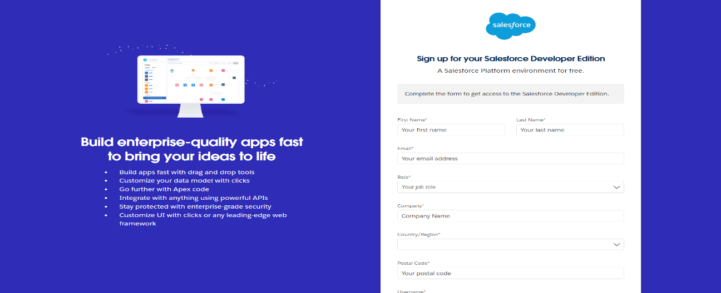

**Fig1.1 Lookup relationship among Objects**

  

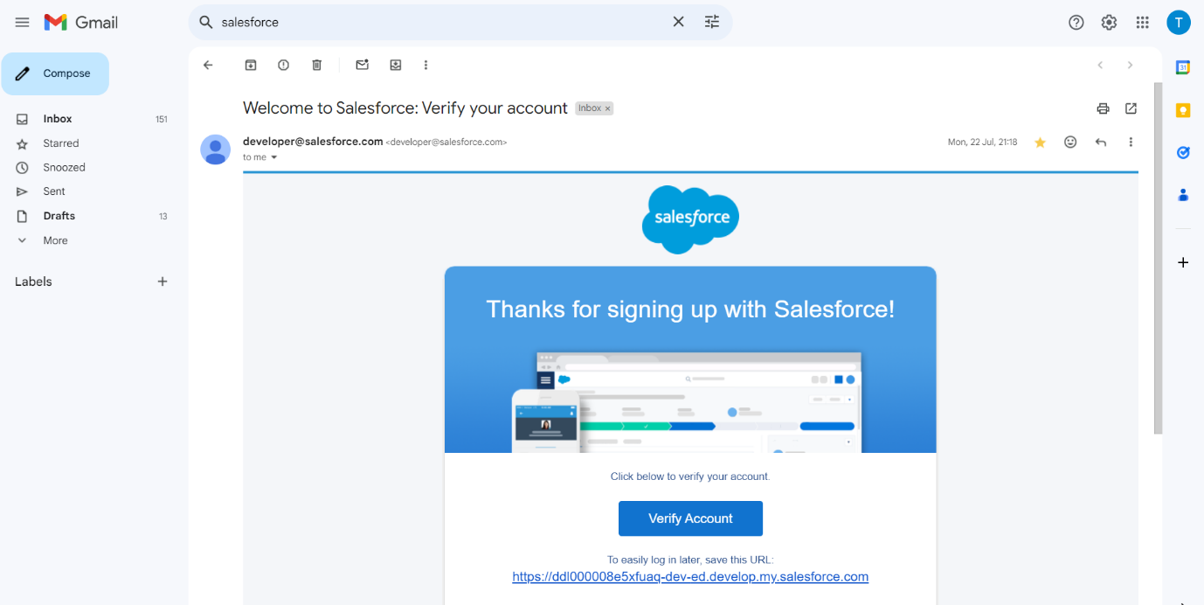

# Fig1.2 Adding items to EduConsultPro

# Fig1.3 EduConsultPro Lightning App

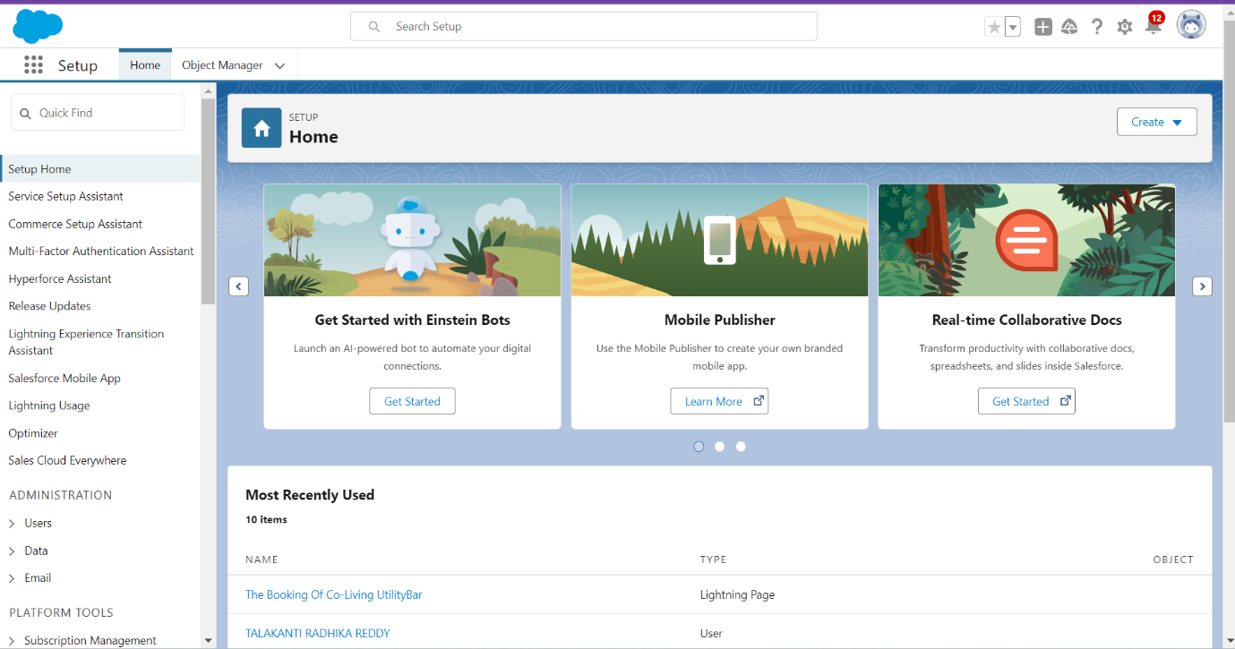

  

3 **SALESFORCE KEY FEATURES AND CONCEPTS UTILIZED**

# TECHNOLOGICAL TRANSFORMATION OF STUDENT REGISTRATION

The EduConsultPro Student Flow represents a sophisticated technological solution designed to revolutionize the institutional registration process by creating an intelligent, user-friendly application ecosystem. This innovative approach leverages Salesforce's advanced technological capabilities to transform traditional registration methodologies into a seamless, integrated experience that prioritizes user engagement and operational efficiency.

# STUDENT INFORMATION CAPTURE MECHANISM

The registration journey begins with a meticulously designed "Student Info" screen element, serving as the primary interface for comprehensive student data collection. By implementing a specialized record variable, the system creates a lightweight, intuitive data capture mechanism that enables efficient retrieval and processing of student information directly from the Salesforce student object. This approach ensures a smooth, user-friendly experience that minimizes administrative friction while capturing critical student details with precision and care.

# RECORD CREATION AND DATABASE INTEGRATION

Upon completing the initial information capture, the system immediately transitions to the "Create Student Record" element, a critical component responsible for saving student input directly into the Salesforce database. This instantaneous record creation ensures real-time data integration, providing immediate validation and system acknowledgment of the student's registration attempt. The process transforms raw input into a structured, meaningful institutional record, laying the foundation for subsequent registration steps.

# COURSE SELECTION AND ROUTING WORKFLOW

The course selection stage represents a pivotal moment in the registration process, implemented through a sophisticated "Course Screen" element. A carefully designed picklist named "Select Course" presents students with comprehensive options including IELTS, GRE, GMAT, Duolingo, and TOEFL. This approach provides students with clear, structured choices while enabling the system to implement intelligent routing mechanisms.

  

The accompanying "Selecting Course" decision element serves as an advanced routing mechanism, dynamically managing the registration flow based on the student's course selection. By implementing conditional logic, the system can retrieve specific course records from the Course object, ensurin g precise, context- aware registration processing. This intelligent routing transforms course selection from a simple choice into a comprehensive, personalized registration pathway.

# REGISTRATION RECORD GENERATION

Following course selection, the system leverages a Create Records element to generate a comprehensive registration record within the Registration object. This critical step associates the selected course with the previously captured student information, creating a holistic registration documentation process. The approach ensures that each registration becomes a rich, multidimensional data point capturing the complete context of the student's institutional engagement.

# COMMUNICATION AND CONFIRMATION STRATEGY

The registration workflow incorporates a sophisticated communication mechanism designed to provide immediate, personalized confirmation. By developing specialized text template resources for email body and subject, the system ensures that students receive comprehensive, timely information about their registration. The "Send Email to Student" action element enables dynamic population of student-specific details, creating a personalized communication experience.

  

# FINAL CONFIRMATION AND USER EXPERIENCE

The registration process culminates in a carefully designed "Success Screen" that provides clear, reassuring confirmation of the completed registration. By displaying a message confirming successful registration and advising students to check their emails, the system creates a positive, supportive conclusion to the enrollment journey.

# STRATEGIC SIGNIFICANCE

The EduConsultPro Student Flow transcends traditional registration systems, emerging as a strategic technological solution that redefines institutional enrollment processes. By combining advanced Salesforce capabilities with a user - centric design philosophy, the implementation creates an intelligent, adaptive ecosystem that enhances both operational efficiency and stakeholder experience.

This comprehensive approach represents a quantum leap in institutional registration technology, transforming what was once a complex, administrative process into a seamless, intelligent, and user-friendly experience.

# SCREENSHOT

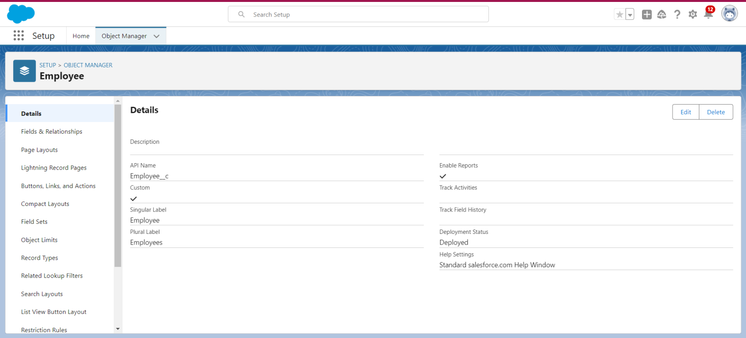

**Fig1.4 EduConsultPro Student Flow**

  

# DETAILED STEPS TO SOLUTION DESIGN CREATE USERS

Created new user in Salesforce by navigating to Setup→Administrative→ Users→New User. Entered "Consultant" for the second name and entered "Salesforce Platform" as the license type. I applied the profile "Standard Platform User," checked all required fields for data, and saved the record of the new user.

Configured user settings: Browse to Setup → Administration → Users → Edit the user profile Scrolled down to the Approver Settings section, selected "Consultant" in the Manager Field, At the bottom of the screen, click Save**.**

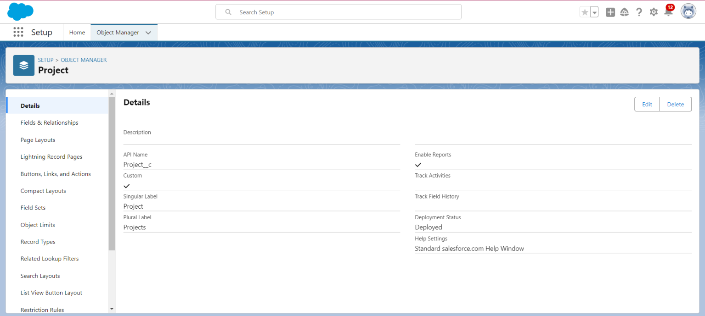

# Fig1.5 User

  

**CREATE AN APPROVAL PROCESS FOR PROPERTY OBJECT**

Created email template in Salesforce. From Setup, I input "Templates" in the Quick Find box and clicked on "Lightning Email Templates", and clicked the toggle to on. Opened the App Launcher, searched for "Email Templates" from the search box, and saved. Created a new folder with the desired name. Created an new email Template and selected the new created folder. The specified text got pasted into the HTML Value to create this, in my case, "Submission Template” Designed two more email templates for approving and rejecting requests, ditto the first one.

Earlier, I did set up the approval process. I went to Setup and typed "Approval" in the Quick Find box, and clicked on "Approval Processes." I selected to manage approval processes for "Appointment" and clicked "Create New Approval Process" using the Jump Start Wizard. I named the process "Appointment Approval" and under the approver settings, I used the setting "Option Automatically assign an approver using a standard or custom hierarchy field" of"Manager." I set the "Next Automated Approver Determined By" field to "Manager."

Made the following changes to the Record Editability Properties: Prepended "Administrator OR the currently assigned approver" to the list Saved the process and checked out the form Made a new Field Update under the Initial Submission Actions with Name "Submitted" and configured it to make the update to the field "Appointment: Status" with "Pending".

Also created a new Email Alert type "Submission Email Alert," auto -populate the Unique Name, selected the "Submission Template" Email Template, selected the recipient type to the user's Name. Repeated that for the Final Approval and Final Rejection actions and set those two up the same way.

# SCREENSHOTS

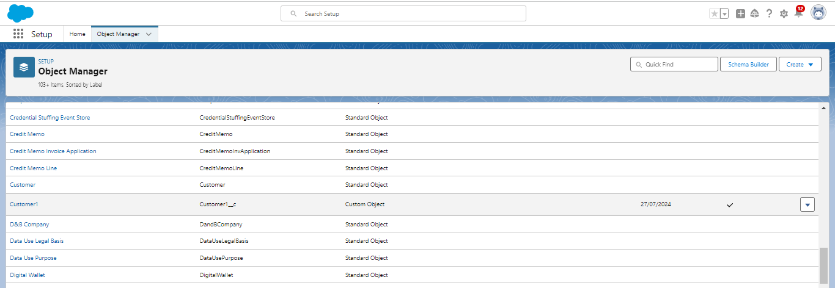

**Fig1.6 Email Template**

  

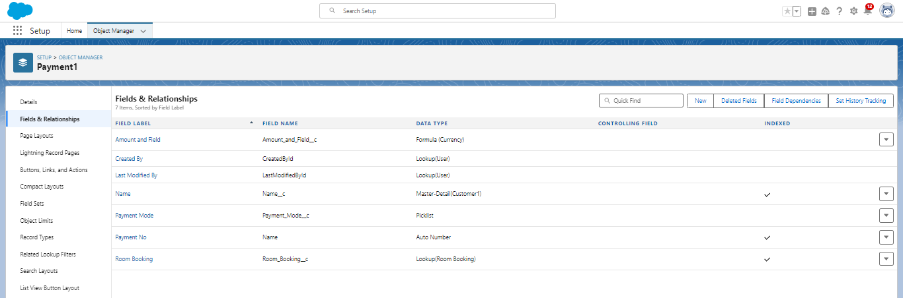

# Fig1.7 Approval Process

**CREATE A RECORD TRIGGERED FLOW**

A **CRM application** designed to manage the services offered by an institution, such as an educational consultancy, aims to streamline operations, track service delivery, and enhance customer experiences.

To create a **Record-Triggered Flow** for such an application, start by selecting the triggering object (e.g., "Student Inquiry" or "Service Request") and defining the entry criteria. This could include conditions such as when the inquiry status is updated to "New" or when a service request is marked "Complete.

" Use actions like "Create Record" to log follow-ups, "Update Record" to modify fields, or "Send Email" to notify relevant stakeholders. Leverage decision elements to guide the flow based on conditions, ensuring a tailored response for each scenario. This approach not only optimizes workflow management but also helps the institution maintain consistent, high-quality service standards.

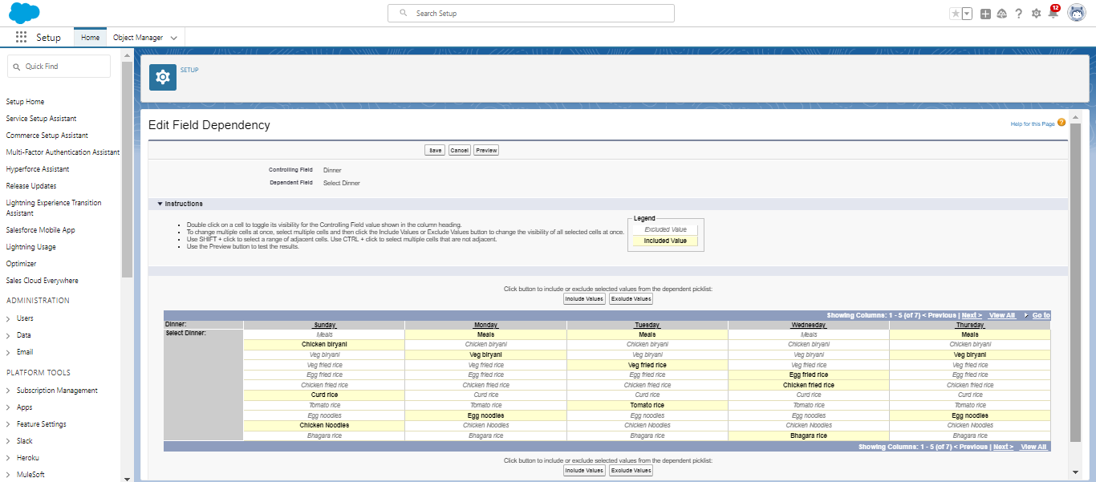

  

**CREATE A SCREEN FLOW FOR EXISTING STUDENT TO BOOK AN APPOINTMENT**

Configured an end-to-end flow in Salesforce for student appointments and cases management. Added a Screen element called "Get Student Info" to collect the student's name and email, and added a GET Record element to retrieve student details depending on the name and email collected.

Added a Decision element to route between "Appointment" and "Case" depending upon the student's wishes. Added a Screen element labeled "Appointment Booking Screen" to gather details for appointments in case an appointment has been booked.

Inserted a GET Record element to obtain consultant details based on the selected name of the consultant. Applied a Create Records element to create a new appointment record with appropriate details.

Added a Screen element and named it "Confirmation Screen" to let the student see details of the appointment confirmation.

Added a Subflow element for case management and named it "Create Student Case" for creation of a case. Finally, save the flow as "EduConsultantPro Existing Student Flow" and prepare for deployment.

# SCREENSHOT

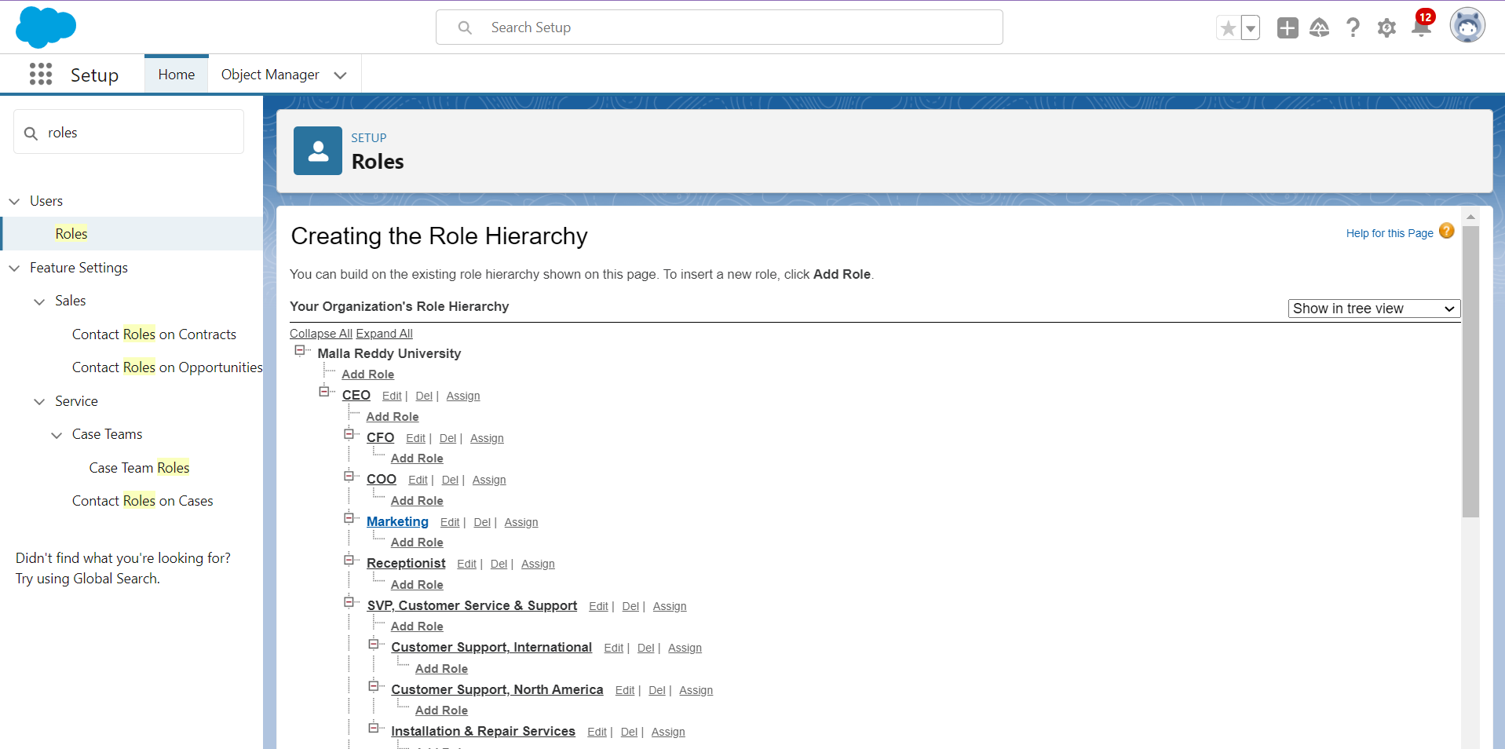

  

# CREATE A SCREEN FLOW TO COMBINE ALL THE FLOWS AT ONE PLACE

A new Screen Element in the flow was added labelled as "Welcome Screen". Inside this screen, a Display Text component was added and was labelled as "Success Message." Entered the given text into the Resource Picker box so that the welcome message by EduConsultantPro describes the services and support it provided. Added another Screen Element following the Welcome Screen, labeled "Existing or New Student Confirmation Screen

Added a Radio Button component with the label "Are you an Existing Student?" Created two choices: "Yes" and "No."Then added an Action Element of type Decision and named it "Decision 1," placing it next to the Existing or New Student Confirmation Screen.Set up the decision criteria with the outcome labeled "If Existing Student." The condition will be when the resource {! Are_you_a_Existing_Student} is equal to the value {! Yes}.Added the second outcome for "No.". Inserted a Subflow Element in the "If Existing Student" path and selected "EduConsultantPro Existing Student Flow" and labelled it as "Existing Student Flow."

Saved the flow under the name "EduConsultantPro Existing Student Flow." Inserted another Subflow Element in the "If Not an Existing Student" path, selecting the "EduConsultantPro Student Flow" and labelling it "New Student Flow." Saved this flow with the name "EduConsultPro Flow.

" Finalized by saving the entire flow, naming it "EduConsultPro Flow.”

# SCREENSHOT

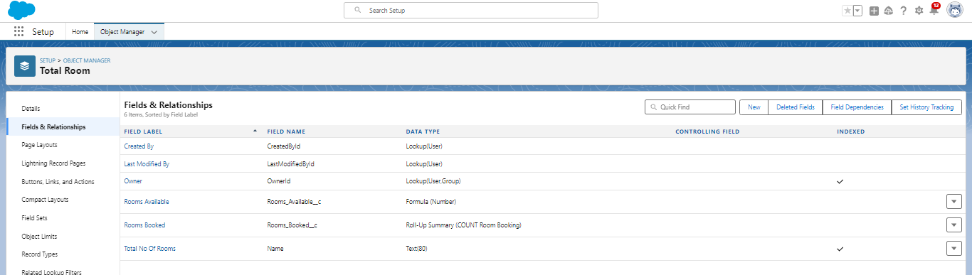

# TESTING AND VALIDATION TESTING

Testing the CRM application, *EduConsultant Pro*, ensures its reliability, functionality, and performance align with institutional needs. During the **unit testing phase**, individual modules, such as user registration, service catalog management, and appointment

  

scheduling, are tested to ensure proper functionality. This is followed by **integration testing**, which verifies that different modules, such as linking client data to service bookings, work together

seamlessly. Furthermore, **system testing** is conducted to validate the application’s overall behaviour under various scenarios, such as handling concurrent user access or retrieving large datasets. Usability testing is also performed to confirm the application is user-friendly and intuitive for consultants and clients.

**Performance and security testing** are critical to ensure the CRM can handle high traffic and protect sensitive client data. Load testing is conducted to analyse how the application performs under stress, while penetration testing identifies potential vulnerabilities that could lead to unauthorized data access. Compatibility testing ensures the CRM works across multiple devices and browsers, delivering a consistent user experience. Issues discovered during testing are documented and fixed to meet the institution’s quality standards.

# VALIDATION

Validation of the *EduConsultant Pro* CRM application ensures it fulfils the business requirements and meets user expectations. This is achieved by conducting **requirement validation**, where the developed features are cross- checked with the original functional specifications. For instance, features like service tracking, report generation, and email notifications are verified to ensure they align with the institution's goals. Validation sessions with stakeholders, including consultants and administrative staff, help ensure the CRM addresses real-world operational needs.

User acceptance testing (UAT) forms a significant part of validation, where end- users interact with the application in a controlled environment. Their feedback is used to determine whether the application is ready for deployment. Validation also includes assessing compliance with legal and regulatory requirements, such

as data protection laws. By thoroughly validating the application, institutions can be confident that *EduConsultant Pro* is not only functional but also tailored to enhance operational efficiency and client satisfaction.

# CREATE A LIGHTNING APP PAGE

The "EduConsultant Pro" CRM application is a cutting-edge solution designed to streamline service management for educational institutions. This application is tailored to meet the needs of administrators, consultants, and students, offering a centralized platform to track and manage interactions, schedules, and services efficiently.With its user-friendly interface and robust functionality, the application ensures that the institution delivers top-notch consulting services while maintaining excellent customer relationships. The Lightning App Page within "EduConsultant Pro" serves as the core interface for managing institutional services. It is built using Salesforce Lightning components, which provide a responsive and dynamic user experience.This page integrates various features, including dashboards to track key performance indicators, service management tools to schedule and monitor consultations, and a comprehensive view of client details. Administrators can quickly access records,

  

manage workflows, and track service delivery using this highly customizable page.

# BENEFITS AND USER EXPERIENCE

The Lightning App Page enhances productivity and ensures seamless communication between consultants and students.

Its visually appealing layout allows users to drag-and-drop components, customize their view, and focus on their priorities.

With real-time updates, automated notifications, and mobile accessibility, the page empowers users to stay connected and informed.

Ultimately, "EduConsultant Pro" elevates service quality and fosters stronger relationships, helping institutions thrive in a competitive educational environment

# 8 KEY SCENARIOS ADDRESSED BY SALESFORCE IN THE IMPLEMENTATION PROJECT

**Optimizing Client Lifecycle Management** Salesforce aids in managing the entire lifecycle of an EduConsultant Pro client, from the initial inquiry stage to the delivery of services. The platform enables centralized tracking of leads, appointments, and consultations, allowing the institution to offer tailored educational consulting services efficiently. Automated appointment scheduling using Salesforce Flow and integration with Einstein AI enables predictive analytics, helping consultants understand client needs proactively. Additionally, the platform’s analytics dashboards provide actionable insights into the institution’s performance, ensuring transparency and continuous improvement in service offerings.

**Enhancing Collaboration and Scalability** With Salesforce, EduConsultant Pro can improve collaboration between departments like marketing, sales, and service teams. The use of Salesforce Chatter fosters real-time communication and information sharing, ensuring all team members are aligned in delivering exceptional services. Moreover, the scalability of Salesforce’s cloud-based infrastructure ensures that the institution can handle growing client bases without compromising performance. By leveraging Salesforce’s AppExchange for industry-specific tools and customizing the CRM as needed, EduConsultant Pro can future-proof its operations while remaining adaptive to evolving client demands.

  

# CONCLUSION:

The contemporary Customer Relationship Management (CRM) application represents a transformative technological solution designed to revolutionize institutional service management through an integrated, holistic approach. By creating a centralized platform that transcends traditional operational boundaries, the application emerges as a sophisticated ecosystem that fundamentally reimagines how institutions interact with their stakeholders, harmonizing technological capabilities with strategic organizational objectives.

The architectural design prioritizes a comprehensive stakeholder experience, creating an interconnected environment that seamlessly bridges communication channels between clients, staff, and administrators. This approach eliminates organizational silos, generating a transparent, responsive platform that enhances institutional effectiveness and service delivery by transforming fragmented processes into a cohesive, intelligent management system.

The system's core functionality is built upon sophisticated, dynamically interconnected modules that work in perfect synchronization. Customer information management serves as the foundational pillar, transforming raw data into strategic relationship intelligence. By developing intricate client profiles that capture detailed interaction histories, preferences, and engagement patterns, the application converts every client interaction into a multidimensional datapoint enabling deeply personalized, context-aware service delivery. Workflow automation emerges as a critical strategic lever for institutional transformation.

By systematically identifying and streamlining repetitive administrative processes, the CRM solution liberates institutional human capital, redirecting focus from transactional tasks to high-value strategic initiatives. Intelligent automation protocols ensure consistent, efficient service deliverywhile maintaining the highest standards of accuracy and personalization, creatingan adaptive ecosystem that can evolve with changing institutional requirements.

Security and scalability are intricately woven into the application's architectural design, ensuring comprehensive data protection, regulatory compliance, and future-ready technological infrastructure. Robust security protocols protect sensitive information while providing flexible, role-based access mechanisms that enable sophisticated user management and data governance.The application's advanced analytics capabilities transform data into strategic insights, providing leadership with comprehensive visualization of institutional performance, stakeholder engagement, and potential optimization opportunities.

  

By generating predictive models and comprehensive performance dashboards, the CRM becomes more than a technological tool—it evolves into a strategic partner driving continuous institutional improvement.Technology integration represents a critical design philosophy, ensuring the CRM can seamlessly connect with existing institutional systems, third-party applications, and emerging technological platforms. This approach creates an

open, adaptable ecosystem that can incorporate new technologies, respond to changing stakeholder needs, and maintain technological relevance in a rapidly evolving digital landscape.

Ultimately, the CRM application transcends traditional service management paradigms, representing a holistic approach to institutional engagement. By combining sophisticated technological capabilities with a deep understanding of stakeholder dynamics, the system creates a transformative platform that enables institutions to deliver exceptional services, build meaningful relationships, and continuously evolve their operational strategies.

# REFERENCES

1. **SalesForce**

# <https://karpagavinayagacollegeof39-dev-ed.develop.my.salesforce.com>

# GuidedProject

# <https://trailhead.salesforce.com/en>

# SmartInternz.

https://nme.smartinternz.com/Student/externships_workspace_info/13936